Subtopic i: Definition of Textile Fibre & Essential Properties
1. Introduction
Everything in textiles starts with a single fundamental unit: the fibre 🧵. Just as cells are the building blocks of the human body, fibres are the building blocks of all yarns and fabrics.
However, not every fibrous material found in nature can be made into a garment. For example, human hair or wood splinters are fibrous, but we cannot spin them into wearable cloth. To be classified as a textile fibre, a material must possess a specific set of physical and mechanical characteristics.

2. Definitions
Simple Definition
A textile fibre is a hair-like strand of matter that is extremely long compared to its thickness, flexible enough to bend, and strong enough to be twisted into yarn.
Technical / Diploma-Level Definition
A textile fibre is a unit of matter characterized by having a length at least 100 times its diameter or width, possessing sufficient strength, flexibility, cohesiveness, and durability to be processed into yarns and textile structures.
TNPSC Definition Alert:
A fibrous material is designated as a textile fibre ONLY if its Length-to-Breadth (L/B) Ratio is at least 100:1 (though commercially useful fibres typically have an L/B ratio exceeding 1000:1).

3. Core Concept: Primary vs. Secondary Properties
Textile fibre properties are divided into two distinct classes:
Primary Properties:
Mandatory requirements. Without these, a fibre cannot be spun into yarn.
Secondary Properties:
Desirable requirements. These determine the fabric's performance, comfort, appearance, and end-use suitability.
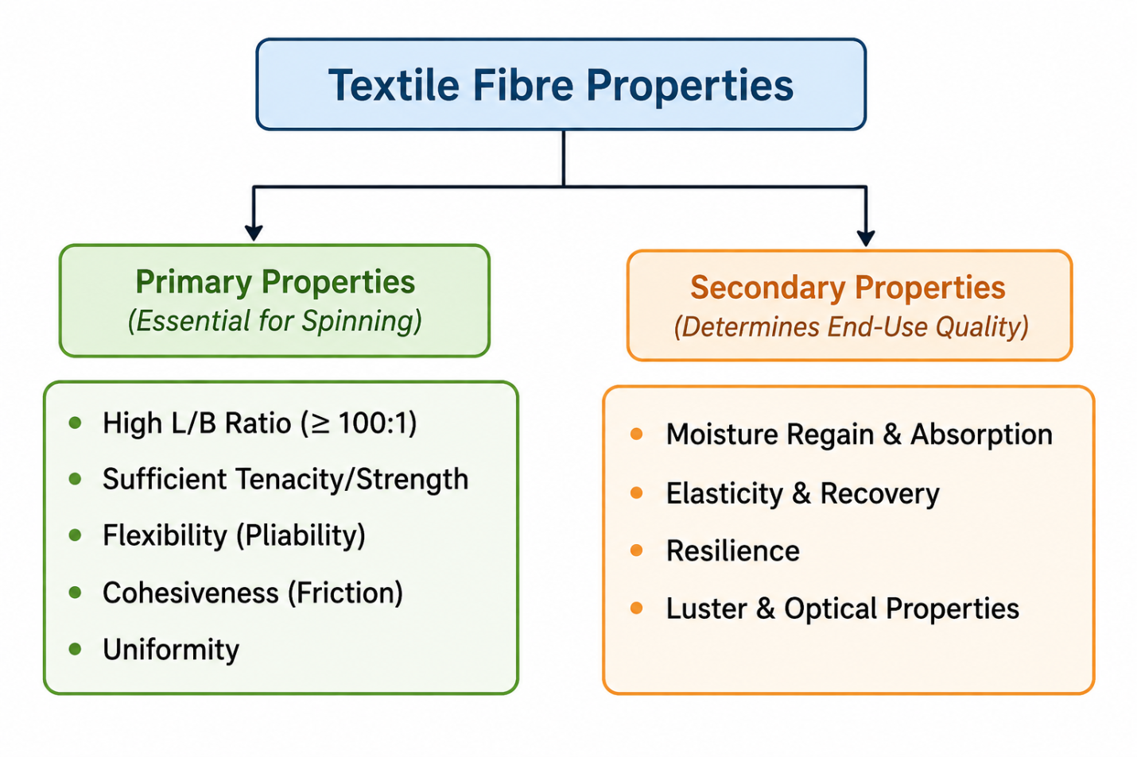

4. Scientific Explanation of Fibre Properties

A. Primary Properties (The "Must-Haves")
1. Length-to-Breadth (L/B) Ratio
Simple Explanation:
The length of the fibre must be vastly greater than its diameter.
Technical Detail:
An L/B ratio of 100:1 is the absolute minimum requirement for fibre-to-yarn conversion. Commercial textile fibres like cotton have L/B ratios around 1000:1 to 1400:1, while filament fibers like silk or synthetic continuous filaments can have L/B ratios in the millions.
Why it matters:
Higher L/B ratio provides more contact area between overlapping fibres, enabling them to bind together securely when twisted.
2. Tenacity (Fibre Strength)
Simple Explanation:
The ability of the fibre to withstand pulling forces without snapping.
Technical Detail:
In textiles, strength is measured as Tenacity (breaking force relative to linear density). Common units include grams per denier (g/den) or centiNewtons per tex (cN/tex). A minimum tenacity of 1.0 to 1.5 g/den is needed to survive high-speed spinning stresses.
Formula:
Tenacity (g/denier) = Breaking Load (g) ÷ Fibre Linear Density (denier)

3. Flexibility / Pliability
Simple Explanation:
The ability to bend easily without cracking or breaking.
Technical Detail:
Flexible polymers allow molecular chains to shift slightly under flexural strain.
4. Cohesiveness (Inter-Fibre Friction)
Simple Explanation:
The tendency of individual fibres to stick to one another when pressed or twisted.
Technical Detail:
Caused by surface roughness, natural crimp (waves), or surface friction.
5. Uniformity
Simple Explanation:
Consistency in length, diameter, and physical characteristics along the length of the fibres.
Why it matters:
Non-uniform fibres cause weak spots, thick/thin places, and yarn breakage during manufacturing.
B. Secondary Properties
Property 🧪 | Technical Definition 📖 | Importance in Textiles 👕
Moisture Regain (MR%) | Percentage weight of moisture a dry fibre absorbs from air under standard conditions ($20^\circ\text{C}$, $65\%\text{ RH}$). | Determines wear comfort, static build-up, and ease of dyeing.
Elastic Recovery | The percentage of original length a fibre recovers after being stretched. | Prevents garments from sagging at knees and elbows.
Resilience | Ability of a fibre to spring back after being compressed/crushed. | Provides wrinkle and crease resistance (e.g., Wool).
Luster | Light reflected from the fibre surface. | Gives shiny or matte visual appearance.
Specific Gravity | Density of the fibre relative to water ($1.0\text{ g/cm}^3$). | Determines fabric weight (e.g., Polypropylene = $0.91\text{ g/cm}^3$, feels light).

6. Memory Techniques
Primary Properties Mnemonic:
L-T-F-C-U
Long Trains Fy Can Usually (Length, Tenacity, Flexibility, Cohesion, Uniformity)

L/B Ratio Rule of Thumb:
100 is the Floor (Minimum needed)
1000 is the Door (Standard for commercial processing)
7. One-Mark Facts
Minimum L/B Ratio: 100:1 (Very high weightage question).
Unit of Fibre Tenacity: g/denier or cN/tex (NOT simply kg or Newtons!).
Definition of Denier: Weight in grams of 9,000 meters of fibre/yarn.
Definition of Tex: Weight in grams of 1,000 meters of fibre/yarn.
Standard Testing Atmosphere:Temperature = 20 ± 2°C
Relative Humidity = 65 ± 2%
Subtopic ii: Classification of Textile Fibres
1. Definitions
Natural Fibres
Fibres that exist in usable fibrous form in nature, obtained directly from plant, animal, or mineral sources without altering their chemical structure.
Man-Made (Manufactured) Fibres
Fibres produced through industrial manufacturing processes where chemical processing or polymer synthesis is required to form the fibre.
TNPSC Definition Alert:
Regenerated Fibres:
Man-made fibres created by dissolving naturally occurring polymers (like wood pulp cellulose) and re-solidifying them into continuous filaments.
Synthetic Fibres:
Man-made fibres synthesized entirely from simple chemical building blocks (monomers/petrochemicals) through polymerisation.
2.Core Concept: The Master Classification Tree
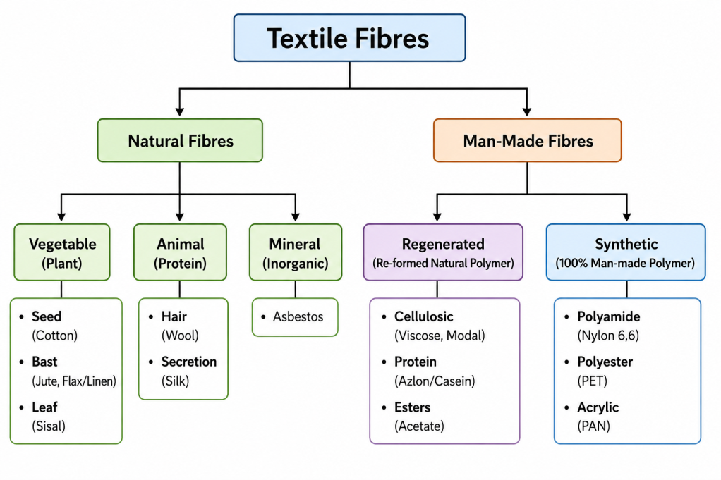
3.Scientific Principle (Chemical Foundations)
Fibre Sub-Class | Primary Chemical Constituent | Building Block (Monomer)
Vegetable (Plant) | Cellulose (C₆H₁₀O₅)ₙ | Glucose units
Animal (Hair/Secretion) | Protein (Keratin – Wool, Fibroin – Silk) | Amino acids
Mineral (Natural) | Hydrated Magnesium Silicate | Inorganic minerals
Regenerated Cellulosic | Purified Cellulose (Wood Pulp/Linters) | Restructured Glucose chains
Synthetic | Synthetic Organic Polymers | Petrochemical Monomers (e.g., Ethylene Glycol, Terephthalic Acid)

4.Detailed Classification Breakdown
A. Natural Fibres
Vegetable (Cellulosic) Fibres:
Seed Fibres: Cotton , Kapok
Bast (Stem) Fibres: Jute, Flax (Linen), Hemp, Ramie
Leaf Fibres: Sisal , Abaca (Manila hemp), Pineapple (Piña)
Fruit/Husk Fibres: Coir (Coconut husk)
Animal (Protein) Fibres:
Animal Hair/Fleece: Wool (Sheep) 🐑, Cashmere, Mohair (Goat), Angora (Rabbit), Camel hair
Animal Secretion: Silk (Silkworm - Bombyx mori)
Mineral Fibres:
Asbestos: Naturally occurring fibrous silicate rock (Fire-resistant, though restricted due to health risks).

B. Man-Made Fibres
Regenerated Fibres (Semi-Synthetic):
Cellulosic Base: Viscose Rayon, High Tenacity (HT) Rayon, Modal, Cuprammonium Rayon, Lyocell (Tencel).
Cellulose Ester: Cellulose Acetate, Triacetate.
Protein Base: Casein (from milk), Zein (from corn).
Synthetic Fibres (100% Synthetic Polymers):
Polyester: Polyethylene Terephthalate (PET).
Polyamide: Nylon 6, Nylon 6,6 .
Polyacrylonitrile (Acrylic): Cashmilon, Orlon.
Polyolefin: Polypropylene (PP), Polyethylene (PE).
Elastomeric: Spandex / Elastane (Lycra).
Inorganic / Metallic Man-Made Fibres:
Glass Fibre, Carbon Fibre, Metallic Fibres (Gold, Silver, Aluminium).
5.Structural Comparison Across Classes
Natural Fibres:
Have irregular cross-sections, natural crimp/twist, limited length (Staple form, except Silk), and complex internal cellular structures (lumen, cuticle, cortex).
Man-Made Fibres:
Manufactured with uniform cross-sections (can be altered via spinneret orifice shape, e.g., circular, trilobal), controllable length (Staple or continuous Filament), and smooth surfaces.

\
6.General Manufacturing / Processing Flow
Natural Fibres
Agricultural Harvesting / Shearing
↓
Extraction / Cleaning
↓
Purified Staple Fibre
Regenerated Fibres
Natural Polymer (Wood Pulp)
↓
Chemical Dissolution
↓
Spinning Solution (Viscous Liquid)
↓
Extrusion through Spinneret
↓
Filament
Synthetic Fibres
Petrochemical Raw Materials
↓
Polymerisation
↓
Synthetic Polymer Chips
↓
Melt / Solution Extrusion
↓
Filament
7.Physical & Chemical Property Trends Across Classes
Property | Vegetable Fibres | Animal Fibres | Regenerated Cellulosic | Synthetic Fibres
Form | Staple only | Staple (Silk = Filament) | Staple & Filament | Staple & Filament
Wet Strength | Stronger when wet (+10–20%) | Weaker when wet (-10–20%) | Significantly weaker when wet (-30–50%) | Unchanged or slightly lower
Moisture Regain | High (7–13%) | Very High (11–16%) | High (11–13%) | Low (0–4.5%)
Acid Effect | Damaged by hot/strong acids | Resistant to mild acids | Damaged by acids | Highly resistant
Alkali Effect | Resistant (Mercerisation) | Damaged by alkalis | Fairly resistant | Resistant
Heat / Flame | Burns; smells like paper | Smolders; smells like burning hair | Burns like paper | Melts and drips

8.Industrial Applications
Vegetable Fibres: Apparel (Cotton), Packaging/Sacks (Jute), Home textiles (Linen).
Animal Fibres: Winter wear, suits, carpets (Wool); Luxury garments, sarees (Silk).
Regenerated Fibres: Fashion apparel, linings, medical dressings (Viscose Rayon).
Synthetic Fibres: Sportswear, activewear, industrial ropes, tire cords (Polyester & Nylon).
Mineral/Glass Fibres: Fireproof curtains, insulation, composites in aerospace and automotive industries.
9.Key Comparison Tables
Vegetable vs Animal Fibres
Property | Vegetable Fibres | Animal Fibres
Chemical Basis | Cellulose | Protein
Elements Present | Carbon, Hydrogen, Oxygen (C, H, O) | Carbon, Hydrogen, Oxygen, Nitrogen (C, H, O, N); Wool also contains Sulphur (S)
Effect of Alkali | Resistant | Damaged / Dissolved
Burning Odour | Burning paper | Burning hair / feathers

Regenerated vs. Synthetic Fibres
Property | Regenerated Fibres | Synthetic Fibres
Source | Natural polymer (Wood pulp) | Petrochemical compounds
Water Absorption | High | Low / Hydrophobic
Thermal Behaviour | Burns without melting | Melts before burning
Static Build-up | Very Low | High

Match the Following Pattern
Fibre | Classification
Sisal | → Leaf Fibre
Flax | → Bast Fibre
Modal | → Regenerated Cellulosic Fibre
Orlon | → Synthetic Acrylic Fibre

Revision Summary
Key Takeaways
- Fibres are broadly classified into Natural and Man-Made.
- Natural fibres include Vegetable (Cellulosic), Animal (Protein), and Mineral.
- Man-Made fibres include Regenerated (re-formed natural polymers) and Synthetic (100% petrochemical polymers).
- Cellulosic fibres become stronger when wet; protein and regenerated cellulosic fibres become weaker when wet.
- Silk is the only natural continuous filament.

Subtopic iii: Microscopic, Physical, and Chemical Test Methods for Fibre Identification
1. 1. Microscopic Identification Method
Microscopic examination looks at two views of a fibre:
Longitudinal View:
The appearance along the length of the fibre.
Cross-Sectional View:
The shape when the fibre is cut perpendicular to its axis.
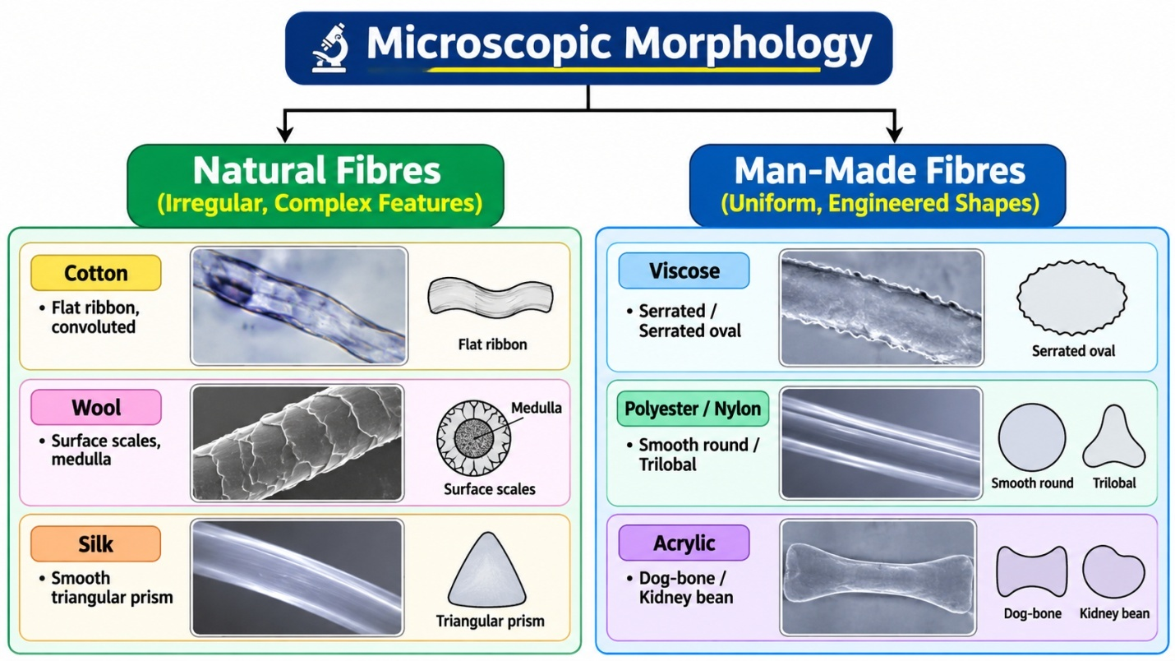

Morphological Characteristics Table
Fibre | Longitudinal View | Cross-Sectional View | Diagnostic Feature
Cotton | Flat, twisted ribbon with natural twists (convolutions) | Kidney-bean / Lima-bean shape with central cavity (lumen) | Natural twists (convolutions) along the length
Flax (Linen) | Straight, smooth fibre with bamboo-like cross-markings (nodes) | Polygonal with a small central lumen | Bamboo-like joints (nodes)
Jute | Smooth fibre with faint longitudinal striations | Polygonal with a wide lumen | Variable lumen width
Wool | Irregular cylindrical fibre with overlapping surface scales | Round to oval (may contain a central medulla) | Surface epidermal scales
Silk | Smooth, structureless rod (often paired) | Triangular with rounded corners | Triangular prism shape produces natural luster
Viscose Rayon | Straight rod with longitudinal striations | Serrated / irregular crenulated outline | Serrated outer edge
Polyester | Smooth, uniform cylinder | Circular (or engineered trilobal) | Highly uniform appearance
Nylon | Smooth, uniform cylinder | Circular | Perfectly uniform cross-section
Acrylic | Smooth or slightly striated fibre | Dog-bone or kidney-bean shape | Distinctive dog-bone cross-section

2. 2. Physical Test: Burning Test Method
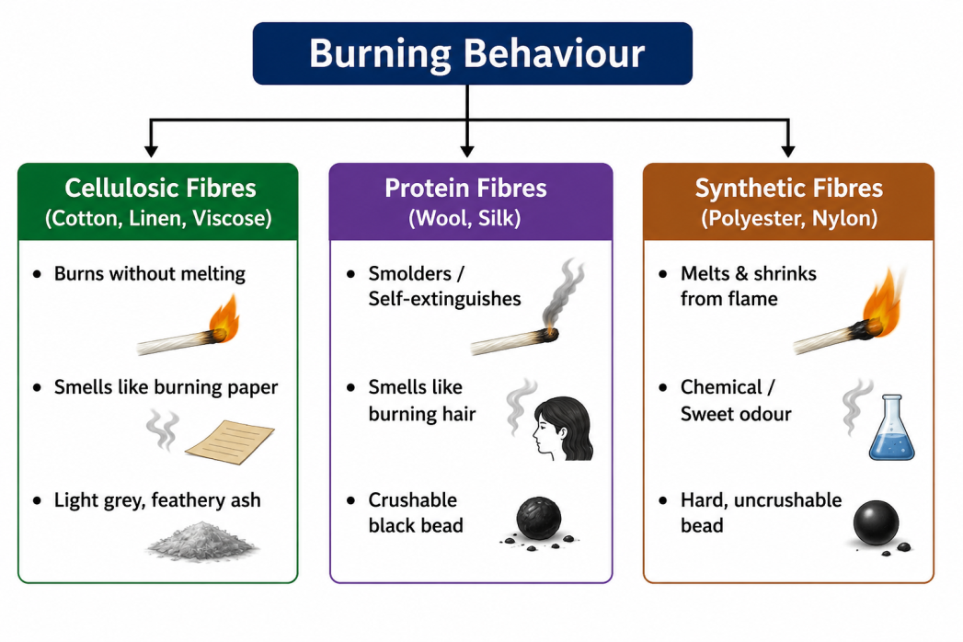
Comprehensive Burning Behavior Guide
Fibre Class | In / Near Flame | Odour | Residue / Ash
Cotton / Linen | Burns rapidly with bright yellow flame; no melting | Burning paper | Light grey, soft feathery ash
Viscose Rayon | Burns rapidly, slightly faster than cotton | Burning paper | Very small amount of grey ash
Wool | Burns slowly with flickering flame; self-extinguishes | Burning hair / feathers | Hollow, dark irregular crushable bead
Silk | Burns slowly; self-extinguishes | Burning feathers / hair | Dark, crushable shiny bead
Polyester | Melts and shrinks away; burns with heavy black smoke | Sweet aromatic / chemical odour | Hard, tough, uncrushable tan/black bead
Nylon | Melts and shrinks; burns slowly | Celery-like odour | Hard, round, uncrushable grey/tan bead
Acrylic | Melts and burns rapidly with sputtering flame | Acrid / Fishy chemical odour | Hard, irregular, brittle black bead

3. 3. Chemical Solubility Test Method
The solubility test is the definitive quantitative and qualitative method for fibre identification, especially in blended fabrics.
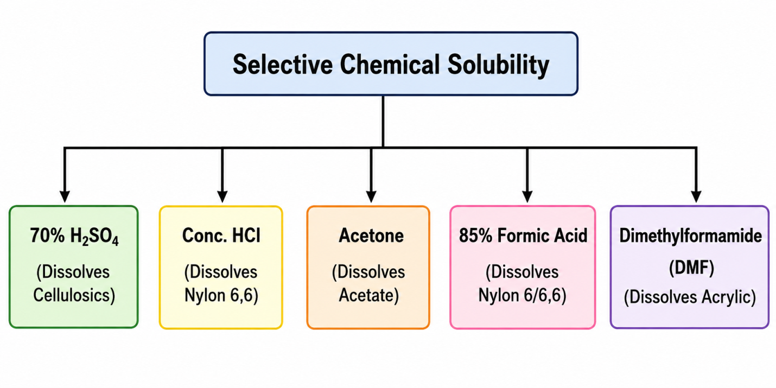

Reagent & Fibre Solubility Chart
Chemical Reagent | Temperature / Condition | Dissolves / Soluble | Insoluble / Unaffected
70% Sulfuric Acid (H₂SO₄) | Room Temperature (20°C) | Viscose Rayon, Cotton, Silk | Polyester, Nylon, Wool, Acrylic
Concentrated Hydrochloric Acid (HCl) | Room Temperature | Nylon 6, Nylon 6,6, Silk | Polyester, Wool, Acrylic, Cotton
85% Formic Acid (HCOOH) | Room Temperature | Nylon 6, Nylon 6,6 | Polyester, Acrylic, Cellulosic Fibres
100% Acetone | Room Temperature | Cellulose Acetate | Triacetate, Viscose, Cotton, Synthetic Fibres
Sodium Hypochlorite (NaOCl, 5% Chlorine) | Room Temperature | Wool, Silk (Protein Fibres) | All Cellulosic and Synthetic Fibres
Dimethylformamide (DMF) | Boiling (90–100°C) | Acrylic (Polyacrylonitrile) | Polyester, Nylon, Cellulosic Fibres
Glacial Acetic Acid | Boiling (100°C) | Acetate Rayon | Viscose, Cotton, Synthetic Fibres
Metacresol / Chlorophenol | Hot (100–130°C) | Polyester (PET) | Nylon, Acrylic, Cellulosic Fibres

4. Memory Techniques
Microscopic Cross-Sections Trick:
Cotton:
Kidney (Kidney bean shape)
Silk:
Triangle (Triangular prism)
Acrylic:
Dog-bone (Dog-bone shape)
Viscose:
Serrated (Serrated edges)
Chemical Solubility Mnemonic:
A F D H S → A N A P P
A → A = Acetone → Acetate
F → N = Formic Acid → Nylon
D → A = DMF → Acrylic
H → P = Hot Metacresol → Polyester
S → P = Sodium Hypochlorite → Protein fibres (Wool & Silk)
Statement-Based MCQ Example
Question:
Statement 1: Cotton and Viscose both dissolve in 70% H₂SO₄ at room temperature.
Statement 2: Nylon and Polyester both dissolve in 85% Formic Acid at room temperature.
Which statement is correct?
B. Statement 1 is True; Statement 2 is False

Subtopic iv: Physical, Chemical Properties & Uses of Vegetable Fibres (Cotton, Jute, Linen)
1. Natural Plant Fibres
Property | Cotton | Jute | Linen (Flax)
Origin | Seed fibre | Bast (Stem) fibre | Bast (Stem) fibre
Botanical Source | Gossypium | Corchorus | Linum usitatissimum
Main Composition | 88–96% Cellulose | 60–65% Cellulose, 12–14% Lignin, 20% Hemicellulose | 70–75% Cellulose, Pectin, 2–5% Lignin
Length | 10–65 mm | Long bast fibre | Ultimate cells: 20–50 mm; Fibre bundles: 30–90 cm
Tenacity | 3.0–5.0 g/den | 3.5–6.0 g/den | 5.5–6.5 g/den
Wet Strength | 10–20% stronger when wet ⭐ | Nearly unchanged | 20% stronger when wet ⭐
Moisture Regain | 8.5% | 12–13.75% | 10–12%
Elongation | 6–9% | 1–2% | 2–3%
Density | 1.54 g/cm³ | ~1.48 g/cm³ | ~1.50 g/cm³
Handle | Soft | Coarse & stiff | Smooth & cool
Crease Resistance | Poor | Poor | Poor

2. Chemical Properties
Property | Cotton | Jute | Linen
Acids | Concentrated acids hydrolyse cellulose | Strong acids damage fibre | Similar to cotton
Alkalis | Highly resistant | Resistant to mild alkalis | Good alkali resistance
Special Treatment | Mercerisation (20–25% NaOH) ⭐ | Woollenisation (18% NaOH) ⭐ | Retting before fibre extraction
Heat Resistance | Up to 150°C | Moderate | Good

Cotton:
- Seed fibre.
- 88–96% cellulose (highest among natural fibres).
- 10–20% stronger when wet.
- Mercerisation: 20–25% NaOH increases:
- Strength
- Luster
- Dye absorption
- Burns like paper and leaves soft grey ash.
Jute:
- Bast fibre.
- High lignin content (12–14%).
- Golden fibre.
- Woollenisation: 18% NaOH softens the fibre.
- Sunlight degrades lignin, causing yellowing and loss of strength.
Linen (Flax)
- Bast fibre from Linum usitatissimum.
- Strongest natural plant fibre.
- 20% stronger when wet.
- High moisture absorbency; cool and comfortable in summer.
- Retting separates fibres from the woody stem.
Easy Memory Trick
Cotton → "MWS"
- M = Mercerisation
- W = Wet stronger
- S = Seed fibre

Jute → "GLW"
- G = Golden fibre
- L = Lignin rich
- W = Woollenisation
Linen → "SRC"
- S = Strongest plant fibre
- R = Retting process
- C = Cool summer fabric
One-Liners
- Cotton → Highest cellulose among natural fibres (88–96%).
- Cotton becomes 10–20% stronger when wet.
- Mercerisation uses 20–25% NaOH on cotton.
- Jute is known as the Golden Fibre.
- Woollenisation of jute uses 18% NaOH.
- Linen is the strongest natural plant fibre.
- Retting is used to extract bast fibres like linen (flax) and jute.

Subtopic v: Animal Fibres – Wool & Silk
1.Core Scientific Principles & Structures:
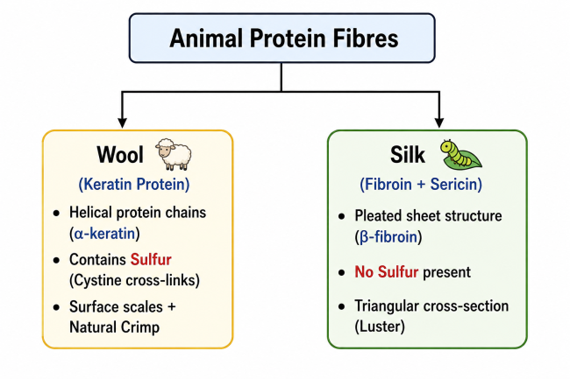

Protein Comparison Table:
Feature | Wool | Silk
Primary Protein | Keratin | Fibroin (75-80%) + Sericin gum (20-25%)
Chemical Elements | Carbon, Hydrogen, Oxygen, Nitrogen, Sulfur ($\text{S}$) | Carbon, Hydrogen, Oxygen, Nitrogen (No Sulfur)
Molecular Shape | Folded/Helical chain ($\alpha$-keratin) | Extended sheet chain ($\beta$-fibroin)
Morphology | Cuticle scales, cortex, central medulla (coarse) | Twin filaments (brins) bound by gum (bave)

2. Physical Properties Comparison
Physical Property 📐 | Wool 🐑 | Silk 🐛
Fibre Form | Staple fibre ($35 - 350\text{ mm}$) | Continuous Filament ($300 - 1200\text{ m}$)
Tenacity (Strength) | $1.0 - 1.7\text{ g/den}$ (Fairly weak) | $3.5 - 4.5\text{ g/den}$ (Very strong)
Wet Strength | Decreases by 10–20% when wet 💧 | Decreases by 15–20% when wet 💧
Moisture Regain (MR%) | $13 - 16\%$ (Highest among natural fibres!) | $11\%$
Elongation at Break | $25 - 35\%$ (Extremely high) | $15 - 25\%$
Resilience & Recovery | Excellent (Wrinkle-resistant) | Good
Density / Specific Gravity | $1.31\text{ g/cm}^3$ | $1.25 - 1.33\text{ g/cm}^3$
Luster | Soft/Muted (due to crimp/scales) | High, rich luster (triangular cross-section)

5. Chemical Properties Comparison
Property | Wool | Silk
Effect of Alkalis | Extremely sensitive; hot dilute alkalis (e.g., 5% NaOH) dissolve wool | Extremely sensitive; hot dilute alkalis (e.g., 5% NaOH) dissolve silk
Effect of Acids | Resistant to mild/dilute organic acids; concentrated mineral acids destroy the fibre | Resistant to mild/dilute organic acids; concentrated mineral acids destroy the fibre
Bleaching Agent | Hydrogen Peroxide (H₂O₂) is preferred | Hydrogen Peroxide (H₂O₂) is preferred
Effect of Chlorine Bleach | Damages fibre and causes yellowing | Damages fibre and causes yellowing
Combustion | Burns slowly, self-extinguishes, smells like burning hair, leaves a dark crushable bead | Burns slowly, self-extinguishes, smells like burning hair/feathers, leaves a dark crushable bead

One Liner:
- Which natural fibre contains 3–4% sulfur?
Wool
- Which amino acid is responsible for sulfur in wool?
Cystine
- Which natural fibre contains no sulfur?
Silk
- Which is the only natural continuous filament fibre?
Silk
- Do wool and silk gain or lose strength when wet?
They lose strength when wet.
- Which natural fibres become stronger when wet?
Cotton and Linen
- What is the process of removing sericin from silk called?
Degumming
- Which protein is removed during degumming?
Sericin
- What causes felting in wool?
Surface epidermal scales and Directional Friction Effect (DFE).
- Which effect is responsible for wool felting?
Directional Friction Effect (DFE).
- Which bleaching agent is safe for wool and silk?
Hydrogen Peroxide (H₂O₂).
- Which bleaching agent should never be used on animal fibres?
Chlorine bleach.
- Why should chlorine bleach not be used on wool and silk?
It damages the fibres and causes yellowing.
- Which animal fibre contains sulfur—wool or silk?
Wool
- Which natural fibre is a continuous filament?
Silk
- Which natural fibre undergoes degumming?
Silk
- Which natural fibre shows felting?
Wool
- Which natural fibre has epidermal scales?
Wool
- What is the full form of DFE?
Directional Friction Effect
- Which two protein fibres lose strength when wet?
Wool and Silk

Subtopic vi: Regenerated Cellulosic Fibres – Viscose Rayon & HT Rayon
1. What is Viscose Rayon?
Viscose Rayon is a regenerated cellulosic fibre. Naturally occurring cellulose (wood pulp or cotton linters) is chemically dissolved to form a viscous liquid called cellulose xanthate, then extruded through a spinneret into an acid bath to regenerate solid pure cellulose filaments.
Wood Pulp (Cellulose)
│

NaOH + CS₂ (Xanthation)
│

Cellulose Xanthate (Viscous Solution)
│

Extrusion through Spinneret into
Dilute H₂SO₄ Acid Bath
│

Regenerated Cellulose Filament
(Viscose Rayon)

2. Key Physical & Chemical Properties
Property 📐 | Regular Viscose Rayon 🧵 | High Tenacity (HT) Rayon 🏋️
Dry Strength | $2.0 - 2.6\text{ g/den}$ | $3.5 - 5.0\text{ g/den}$
Wet Strength | Loses 30–50% strength when wet 💧 | Loses only 15–25% strength when wet
Moisture Regain | $11 - 13\%$ (Highly absorbent) | $11 - 12\%$
Cross-Section | Serrated / Crenulated outline ⚙️ | Smooth, nearly round outline
Structure | Lower orientation & crystallinity | High orientation & alignment

Chemical Reactions:
Acids:
Mineral acids ($H_2SO_4$, $HCl$) hydrolyze and dissolve viscose. It completely dissolves in 70% $H_2SO_4$ at room temperature.
Alkalis:
Resistant to weak alkalis, but strong NaOH causes swelling.

Subtopic vii: Synthetic Fibres – Polyester, Nylon 6,6, and Acrylic
1.Monomers & Chemical Foundations
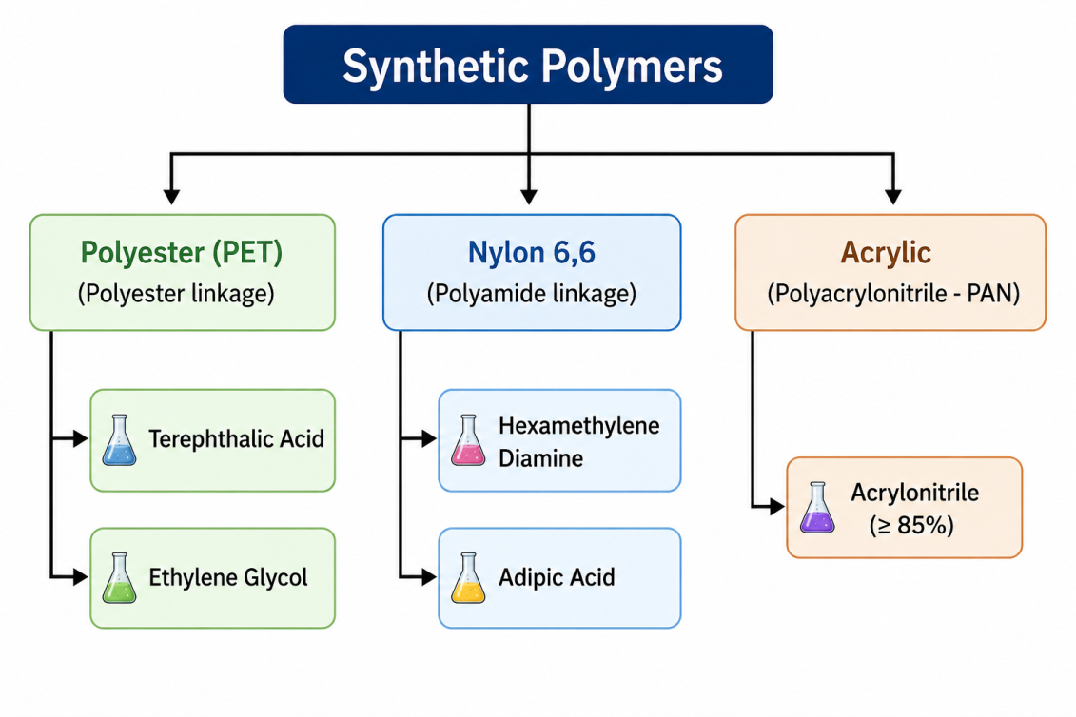
Synthetic Fibre 🧵 | Monomers / Building Blocks 🧪 | Polymer Linkage 🔗 | Specific Gravity ⚖️ | Moisture Regain 💧
Polyester (PET) | Dimethyl Terephthalate (DMT) / Terephthalic Acid (TPA) + Ethylene Glycol (EG) | Ester ($-COO-$) | $1.38\text{ g/cm}^3$ | $0.4\%$
Nylon 6,6 | Hexamethylene Diamine + Adipic Acid (6 carbons each) | Amide ($-CONH-$) | $1.14\text{ g/cm}^3$ | $4.0 - 4.5\%$
Acrylic | Polyacrylonitrile ($\ge 85\%$ Acrylonitrile monomer) | Nitrile ($-CN$) | $1.17\text{ g/cm}^3$ | $1.5 - 2.0\%$

2. Physical & Chemical Properties Comparison
Property 📐 | Polyester (PET) 🛢️ | Nylon 6,6 🧵 | Acrylic 🧪
Tenacity (Strength) | $4.5 - 7.0\text{ g/den}$ (Very High) | $4.5 - 8.5\text{ g/den}$ (Highest tenacity) | $2.0 - 3.5\text{ g/den}$ (Moderate)
Abrasion Resistance | Excellent | Superior / Best among all fibres 🥇 | Fair to Good
Elastic Recovery | Excellent | Exceptional | Good
Resilience / Crease Recovery | Best wrinkle recovery 👔 | High | High (Feels like Wool)
Effect of Acids | Resistant to cold mineral acids | Damaged by mineral acids | Highly resistant
Effect of Alkalis | Damaged by hot/strong alkalis | Highly resistant | Resistant to weak alkalis
Key Selective Solvent | Hot Metacresol / Chlorophenol | 85% Formic Acid / Conc. $HCl$ | Dimethylformamide (DMF)

3. Specific Fibre Features & Applications
1. Polyester (Polyethylene Terephthalate - PET)
Key Feature: High Dimensional Stability and Shape Retention.
Drawback: Prone to Pilling (formation of small fibre balls on fabric surface) and static build-up.
Uses: Blended fabrics (Polyester-Cotton / "Poly-cot"), suitings, plastic bottles (PET), sailcloth.

2. Nylon 6,6 (Polyamide)
Key Feature: Exceptional toughness, flexibility, and abrasion resistance.
Drawback: Degrades under prolonged sunlight (UV exposure) and turns yellow.
Uses: Hosiery, carpets, parachutes, fishing nets, high-strength ropes, tire cords.
3. Acrylic (Polyacrylonitrile)
Key Feature: Warm, lightweight, bulked texture; often called "Synthetic Wool".
Types: Modacrylic contains $35-85\%$ acrylonitrile and is highly flame-retardant.
Uses: Sweaters, blankets, shawls, faux fur, outdoor awnings (UV resistant).
4. Memory Techniques
Selective Solvents Trick:
N-F - Nylon dissolves in Formic acid (85%).
A-D - Acrylic dissolves in DMF (Dimethylformamide).
P-M - Polyester dissolves in Metacresol.
Fibre Nicknames:
Nylon: The "Self-recovering / High-Abrasion King".
Acrylic: The "Synthetic Wool".
Polyester: The "Wrinkle-Free Champion".

Subtopic viii: Fibre-Forming Polymers & Spinning Methods
1.Requirements of Fibre-Forming Polymers
Not every polymer can be converted into a textile fibre. A polymer must possess the following properties to be fibre-forming.

1. High Molecular Weight (High Degree of Polymerisation)
- Polymer chains must be very long (DP > 100).
- Long chains become entangled, giving high tensile strength.
- Short chains produce weak and brittle fibres.
2. Linear Chain Structure
- Polymer molecules should be linear or only slightly branched.
- Linear chains can pack closely together.
- Close packing improves strength and fibre formation.
3. Strong Intermolecular Forces (Polar Groups)
The polymer should contain polar functional groups such as:
- OH (Hydroxyl)
- NH–CO– (Amide)
- COO– (Ester)
These groups form hydrogen bonds or dipole–dipole forces between neighbouring chains.
Strong intermolecular forces increase fibre strength and stability.
4. Orientation and Crystallinity
- Polymer chains should be capable of aligning parallel to the fibre axis during spinning and drawing.
- Aligned chains form crystalline regions.
- Higher crystallinity improves:
- Strength
- Stiffness
- Dimensional stability
5. High Melting or Softening Point
- A textile fibre must withstand normal use.
- It should resist heat during
- Washing
- Ironing
- Drying
Therefore, fibre-forming polymers generally have a melting or softening point above 200°C.
2. The Three Master Polymer Spinning Methods
"Spinning" in man-made fibres refers to extruding a liquid polymer through tiny holes in a nozzle called a Spinneret to form solid filaments.
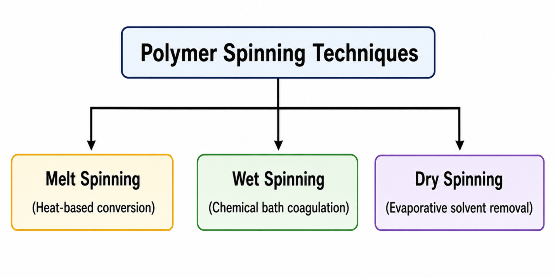
A.Melt Spinning
Principle:
Polymer chips are melted by heat, forced through a spinneret, and solidified by cooling air.
Requirements:
Polymer must melt without thermally degrading.
Fibres Produced:
Polyester, Nylon 6, Nylon 6,6, Polypropylene.
B. Wet Spinning
Principle:
Polymer is dissolved in a solvent, extruded into a liquid chemical coagulation bath, where the polymer precipitates into solid filaments.
Requirements:
Polymer cannot be melted safely and requires solvent dissolution.
Fibres Produced:
Viscose Rayon, Acrylic (PAN), Cuprammonium Rayon.
C. Dry Spinning
Principle:
Polymer is dissolved in a volatile solvent, extruded into a warm air chamber, where the solvent evaporates, leaving behind solid filaments.
Fibres Produced:
Cellulose Acetate, Acrylic, Spandex (Elastane).
Comparison Table: Polymer Spinning Methods
Parameter 📐 | Melt Spinning 🌡️ | Wet Spinning 🧪 | Dry Spinning 💨
State of Polymer | Molten fluid | Polymer solution in solvent | Polymer solution in volatile solvent
Solidification Agent | Cool air current ❄️ | Chemical coagulation bath 🛁 | Warm air stream (Evaporation) 🌬️
Spinning Speed | Extremely high ($1000 - 6000\text{ m/min}$) | Lowest ($50 - 200\text{ m/min}$) | Medium ($300 - 1000\text{ m/min}$)
Solvent Recovery? | Not required | Required (Complex) | Required (Volatile recovery)
Cross-Section Shape | Circular / Uniform | Serrated / Irregular | Dog-bone / Peanut shape
Environmental Impact | Cleanest & cheapest | Produces liquid effluent | Solvent vapour hazards

Subtopic ix: Post-Spinning Operations – Drawing, Crimping, Heat Setting & Texturisation
When synthetic filaments emerge from a spinneret during melt, wet, or dry spinning, they are called "as-spun" filaments. At this stage, they are weak, highly extensible, smooth, and dimensionally unstable because their polymer chains are randomly oriented.
To convert these raw filaments into strong, commercially useful textile yarns, they must undergo post-spinning operations .
1.Drawing(Stretching)
What is Drawing?
Drawing is the process of stretching as-spun filaments longitudinally to several times their original length (defined by the Draw Ratio).
As-Spun Filament 🧵
│
Drawing (Stretching)
│
Chains Become Oriented
│
High Strength (Tenacity)

Purpose & Scientific Principle
Polymer Chain Alignment:
Forces amorphous, randomly tangled polymer chains to align parallel to the fibre axis.
Crystallinity Increase:
Brings chains closer together, forming strong intermolecular hydrogen bonds or van der Waals forces.
Property 📐 | Before Drawing (As-Spun) | After Drawing 📈
Polymer Orientation | Low / Random | High / Parallel to axis
Tenacity (Strength) | Very Low | Significantly Increased
Elongation at Break | Very High ($300 - 500\%$) | Decreased ($15 - 30\%$)
Linear Density (Denier) | Coarse / Thick | Finer / Thin

2.Crimping
What is Crimping?
Crimping imparts 2D or 3D waves, folds, or saw-tooth bends along the length of continuous filaments.
Purpose & Scientific Principle
Inter-Fibre Cohesion:
Synthetic staple fibres are naturally smooth. Adding crimp gives them surface friction so they hold together during yarn spinning (carding and drafting).
Bulk & Warmth: Traps air within the structure, improving thermal insulation and bulkiness (mimicking natural wool .

3. Heat Setting
What is Heat Setting?
Heat setting is a thermal treatment where thermoplastic fibres (like Polyester, Nylon, or Acrylic) are heated under tension to a specific temperature, held for a set time, and then cooled.
Temperature Condition
Glass Transition Temperature (Tg)
│
Polymer Becomes Soft & Flexible
│
Heat Setting Temperature
│
(Shape is Permanently Set)
│
Melting Temperature (Tm)
│
Polymer Melts
Scientific Principle
Stress Relaxation:
Heating above $T_g$ weakens weak intermolecular bonds in amorphous regions, allowing locked-in internal stresses from drawing to relax.
Re-bonding:
Cooling forms new, stress-free hydrogen/intermolecular bonds in the new shape.

Key Benefits :
Prevents garment shrinkage during hot washing and ironing .
Provides excellent dimensional stability and crease resistance.
4. Texturisation
What is Texturisation?
Texturisation converts smooth, flat continuous filament yarns into bulky, stretchy, textured yarns with a natural fiber-like feel.
Flat Filament Yarn
(Smooth • Cold • Shiny)
│
▼
Texturisation Process
│
▼
Crimp / Loops / Bulk Created
│
▼
Textured Yarn
(Bulky • Warm • Elastic • Matte Finish)

Method ⚙️ | Working Principle 🔬 | Key Characteristics / End-Uses 👕
False Twist Texturisation (FTT) | Yarn is twisted, heat-set above $T_g$, and untwisted in a continuous step. | High stretch and high bulk. Used in hosiery, sportswear, and stretch fabrics.
Air-Jet Texturisation | High-velocity compressed air creates loops in filaments without heat. | Purely mechanical process. Produces a soft, spun-yarn feel. Suitable for non-thermoplastic yarns too!
Stuffer Box | Filaments are crammed tightly into a heated chamber to form saw-tooth crimps. | High bulk, moderate stretch. Used in carpet yarns.
Edge Crimping | Filament is pulled over a sharp heated blade (like curling ribbon with scissors). | Creates a asymmetric spiral crimp. Used in hosiery.
Knit-de-Knit | Filament is knitted into a tube, heat-set, and unravelled. | Produces a crinkled/wavy texture.

